

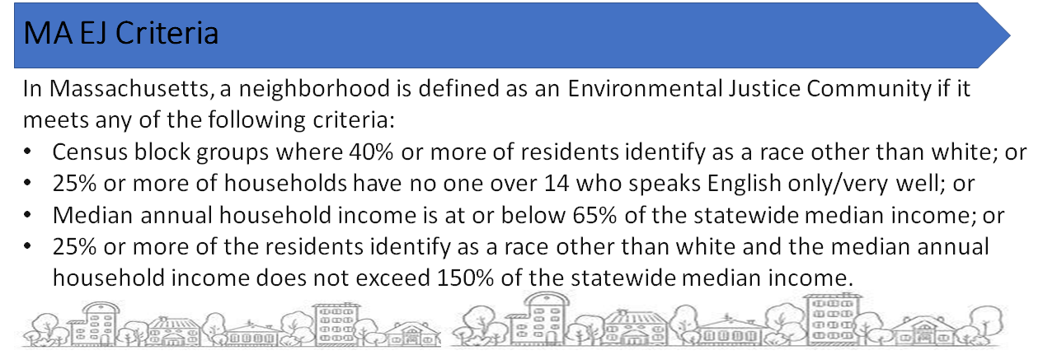


A Newsletter of the Massachusetts Department of Public Health Bureau of Climate and Environmental Health
Environmental Public Health Tracking Program
2024 Volume 5, Issue 1

News and Updates

Content Update:
- Check out the Radon Blog about how the danger of radon in homes was discovered.

Data Update:
- Drinking Water data to 2020.
- Recreational Beach data to 2023.
- Hospitalization data (Asthma, Carbon Monoxide Poisoning, COPD, Heart Attack, and Heat Stress) to 2021.

Featured Topic: Choose Safe Places for Early Care and Education
Many young children spend more time at child care programs than anywhere else outside of their homes. Thus, child care programs play an important role in keeping children safe. The voluntary Choose Safe Places for Early Care and Education (Choose Safe Places) program helps child care educators choose locations that are safe from environmental hazards and offers free resources to help early childhood programs keep children safe from toxic chemicals. Choose Safe Places is a collaboration between the Massachusetts Department of Public Health (DPH) and MA Department of Early Education and Care (EEC).
Environmental Justice (EJ) neighborhoods host a disproportionate concentration of contaminated sites. Considering that children are particularly sensitive to harmful chemicals and that EJ neighborhoods are unduly burdened by environmental pollution, it is imperative that child care programs be safely sited in these communities.
Using maps and data from the MA Environmental Public Health Tracking Program (EPHT), we illustrate opportunities for Choose Safe Places to protect children from environmental hazards, particularly in EJ areas. We focused our analysis on southeastern MA.
The MA Executive Office of Energy and Environmental Affairs Environmental Justice Policy defines EJ neighborhoods as US Census Bureau census block groups that meet at least one criterion for income, community of color, or English isolation.

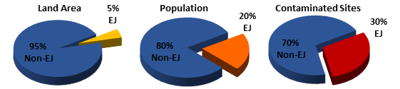
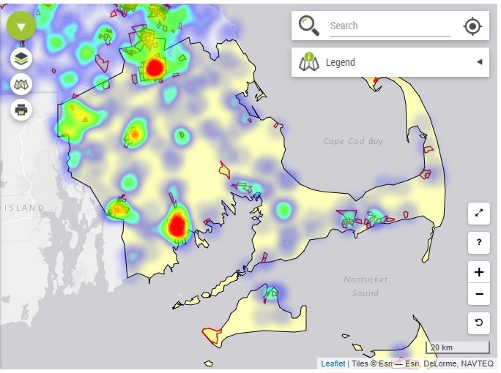
Burden of Contaminated Sites within EJ Neighborhoods in Southeastern Massachusetts: EJ neighborhoods make up just 5% of the land area in the southeastern MA region, but are home to 20% of the population, 25% of children under the age of 5 years, and 30% of regulated contaminated sites.

Using EPHT mapping tools to visualize land area, EJ populations, and contaminated sites, we created the visualization shown here.
We started by building a map using EPHT’s pediatric asthma data and then added the following layers:
- EJ neighborhoods (outlined in red)
- Contaminated sites (density indicated by heat mapping option)
The heat map displays areas with a high density of contaminated sites in red, orange, and yellow and areas with a low density of contaminated sites in blue and green. Looking at the map, hotspots with a high density of contaminated sites in EJ neighborhoods are most noticeable in Brockton to the north and New Bedford to the south (circled in red). Additional EJ
neighborhoods with a high density of contaminated sites also appear in Taunton and Fall River (circled in blue) among smaller hotspots. These four communities with dense concentrations of contaminated sites account for 76% of the EJ populations in southeastern MA. This map shows the intersection of EJ neighborhoods and contaminated sites where potential health hazards exist. You can create similar maps using our tutorials.
Opportunities for the Choose Safe Places Program
The Choose Safe Places program provides a key service to prevent environmental exposures among children and staff at child care programs by promoting safe siting.
- Approximately 900 licensed group and school-aged child care programs in southeastern MA are located in communities with EJ populations.
- The higher burden of contaminated sites within EJ neighborhoods underscores the importance of safe siting of child care programs.
For more information, visit the Choose Safe Places website, find information under Planning & Tools on EPHT, or send an email to ChooseSafePlaces@mass.gov.

MA EPHT Website | CDC’s National EPHT Program | DPH Bureau of Climate and Environmental Health
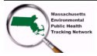

The MA EPHT website has many features that can help you get the health and environmental information you need. To contact us, call 1-617-624-5757 and ask for the "EPHT Coordinator".
This work is partially supported by the Environmental Public Health Tracking Network Cooperative Agreement (CDC-RFA-EH22-2202) to the Massachusetts Department of Public Health by the U.S. Centers for Disease Control and Prevention. The content of this publication does not necessarily reflect the official views of the Centers for Disease Control and Prevention of the Department of Health and Human Services.
unsubscribe from this list | view email in browser

